SEC Form 3
FORM 3 | UNITED STATES SECURITIES AND EXCHANGE COMMISSION  Washington, D.C. 20549  INITIAL STATEMENT OF BENEFICIAL OWNERSHIP OF SECURITIES  Filed pursuant to Section 16(a) of the Securities Exchange Act of 1934  or Section 30(h) of the Investment Company Act of 1940
  OMB APPROVAL
  OMB Number: | 3235-0104
  Estimated average burden
  hours per response: | 0.5
1. Name and Address of Reporting Person*  (Street) | 2. Date of Event Requiring Statement (Month/Day/Year)  08/10/2026 | 3. Issuer Name and Ticker or Trading Symbol  Viant Technology Inc. [ DSP ]  Foreign Trading Symbol
  Abrahams Craig Justin
  (Last) | (First) | (Middle)
  C/O VIANT TECHNOLOGY INC.
  2722 MICHELSON DRIVE, SUITE 100
  IRVINE | CA | 92612
  (City) | (State) | (Zip)
 |  | 4. Relationship of Reporting Person(s) to Issuer  (Check all applicable) | 5. If Amendment, Date of Original Filed (Month/Day/Year)
   | Director |  | 10% Owner
   | Officer (give title below) |  | Other (specify below)
6. Individual or Joint/Group Filing (Check Applicable Line)
Form filed by One Reporting Person
Form filed by More than One Reporting Person

Table I - Non-Derivative Securities Beneficially Owned
1. Title of Security (Instr. 4) | 2. Amount of Securities Beneficially Owned (Instr. 4) | 3. Ownership Form: Direct (D) or Indirect (I) (Instr. 5) | 4. Nature of Indirect Beneficial Ownership (Instr. 5)
Table II - Derivative Securities Beneficially Owned
(e.g., puts, calls, warrants, options, convertible securities)
1. Title of Derivative Security (Instr. 4) | 2. Date Exercisable and Expiration Date (Month/Day/Year) |  | 3. Title and Amount of Securities Underlying Derivative Security (Instr. 4) |  | 4. Conversion or Exercise Price of Derivative Security | 5. Ownership Form: Direct (D) or Indirect (I) (Instr. 5) | 6. Nature of Indirect Beneficial Ownership (Instr. 5)
1. Title of Derivative Security (Instr. 4) | Date Exercisable | Expiration Date | Title | Amount or Number of Shares | 4. Conversion or Exercise Price of Derivative Security | 5. Ownership Form: Direct (D) or Indirect (I) (Instr. 5) | 6. Nature of Indirect Beneficial Ownership (Instr. 5)
Explanation of Responses:
Remarks:
Exhibit List: Exhibit 24 - Power of Attorney.
No securities are beneficially owned.
 | /s/ Larry Madden, Attorney-In-Fact for Craig Justin Abrahams | 08/12/2026
 | ** Signature of Reporting Person | Date
Reminder: Report on a separate line for each class of securities beneficially owned directly or indirectly.
* If the form is filed by more than one reporting person, see Instruction 5 (b)(v).
** Intentional misstatements or omissions of facts constitute Federal Criminal Violations See 18 U.S.C. 1001 and 15 U.S.C. 78ff(a).
Note: File three copies of this Form, one of which must be manually signed. If space is insufficient, see Instruction 6 for procedure.
Persons who respond to the collection of information contained in this form are not required to respond unless the form displays a currently valid OMB Number.
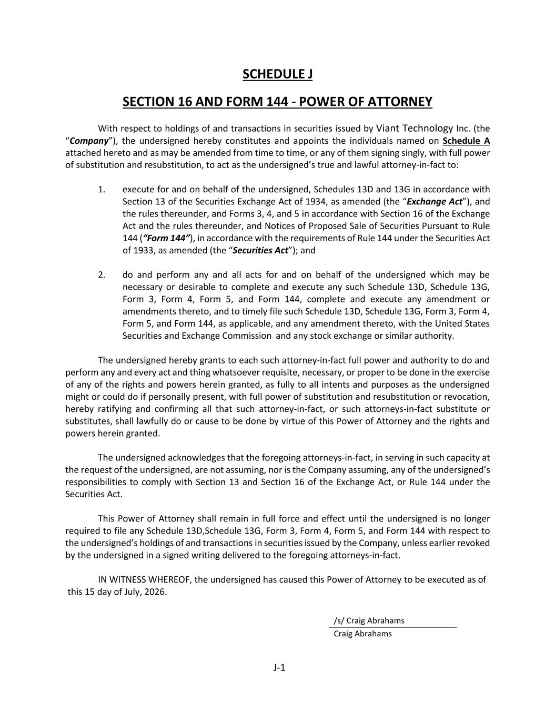
J-1 SCHEDULE J SECTION 16 AND FORM 144 - POWER OF ATTORNEY With respect to holdings of and transactions in securities issued by Viant Technology Inc. (the “Company”), the undersigned hereby constitutes and appoints the individuals named on Schedule A attached hereto and as may be amended from time to time, or any of them signing singly, with full power of substitution and resubstitution, to act as the undersigned’s true and lawful attorney-in-fact to: 1. execute for and on behalf of the undersigned, Schedules 13D and 13G in accordance with Section 13 of the Securities Exchange Act of 1934, as amended (the “Exchange Act”), and the rules thereunder, and Forms 3, 4, and 5 in accordance with Section 16 of the Exchange Act and the rules thereunder, and Notices of Proposed Sale of Securities Pursuant to Rule 144 (“Form 144”), in accordance with the requirements of Rule 144 under the Securities Act of 1933, as amended (the “Securities Act”); and 2. do and perform any and all acts for and on behalf of the undersigned which may be necessary or desirable to complete and execute any such Schedule 13D, Schedule 13G, Form 3, Form 4, Form 5, and Form 144, complete and execute any amendment or amendments thereto, and to timely file such Schedule 13D, Schedule 13G, Form 3, Form 4, Form 5, and Form 144, as applicable, and any amendment thereto, with the United States Securities and Exchange Commission and any stock exchange or similar authority. The undersigned hereby grants to each such attorney-in-fact full power and authority to do and perform any and every act and thing whatsoever requisite, necessary, or proper to be done in the exercise of any of the rights and powers herein granted, as fully to all intents and purposes as the undersigned might or could do if personally present, with full power of substitution and resubstitution or revocation, hereby ratifying and confirming all that such attorney-in-fact, or such attorneys-in-fact substitute or substitutes, shall lawfully do or cause to be done by virtue of this Power of Attorney and the rights and powers herein granted. The undersigned acknowledges that the foregoing attorneys-in-fact, in serving in such capacity at the request of the undersigned, are not assuming, nor is the Company assuming, any of the undersigned’s responsibilities to comply with Section 13 and Section 16 of the Exchange Act, or Rule 144 under the Securities Act. This Power of Attorney shall remain in full force and effect until the undersigned is no longer required to file any Schedule 13D,Schedule 13G, Form 3, Form 4, Form 5, and Form 144 with respect to the undersigned’s holdings of and transactions in securities issued by the Company, unless earlier revoked by the undersigned in a signed writing delivered to the foregoing attorneys-in-fact. IN WITNESS WHEREOF, the undersigned has caused this Power of Attorney to be executed as of this 15 day of July, 2026. /s/ Craig Abrahams Craig Abrahams

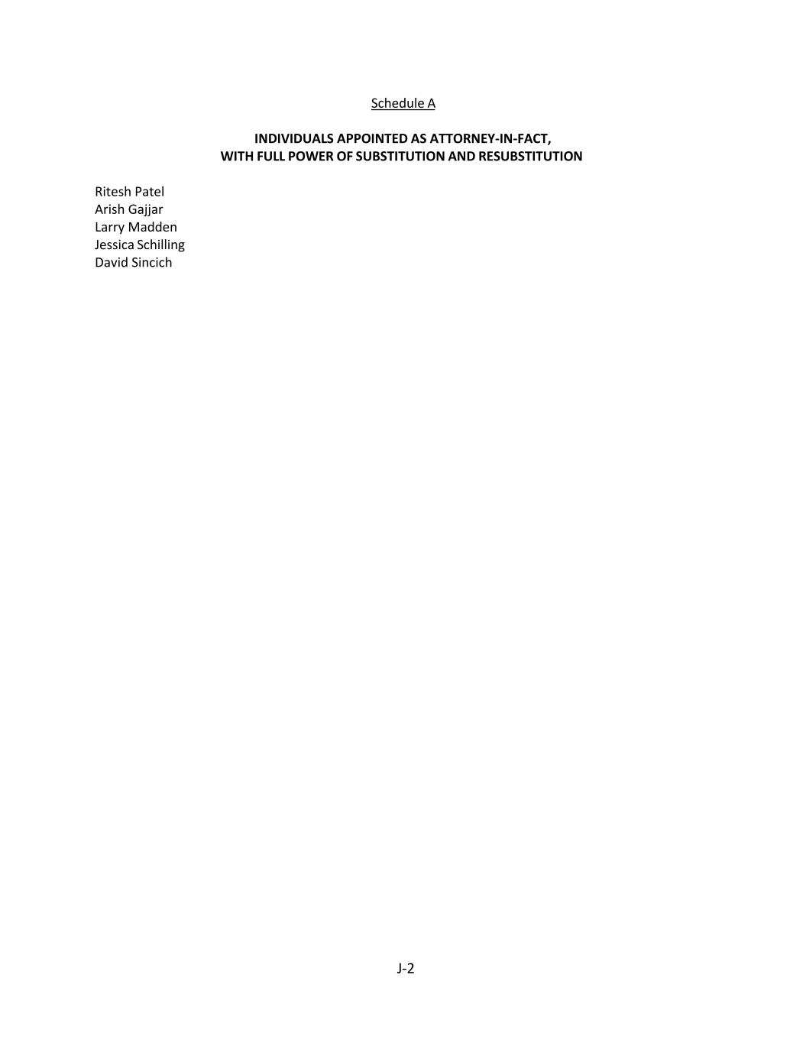
J-2 Schedule A INDIVIDUALS APPOINTED AS ATTORNEY-IN-FACT, WITH FULL POWER OF SUBSTITUTION AND RESUBSTITUTION Ritesh Patel Arish Gajjar Larry Madden Jessica Schilling David Sincich

